|  |  |  |
| --- | --- | --- |
| Supervisor | **Muhammad Hamza** | |
| Batch | **2309G3** | |
| Group | **C** | |
| Serial No. | **Enrollment Number** | **Student Name** |
| 1. | Student1507026 | Muhammad Umair |
| 2. | Student1507111 | AbdulAhad Hussain |
| 3. | Student1508383 | Shahzaib Ali Zahid |
| 4. | Student1501118 | Muhammad Shafay Shaikh |

Fun Zone

**Home Page**

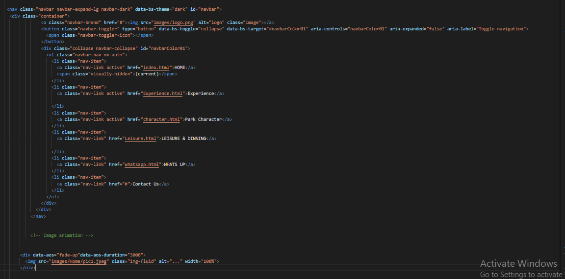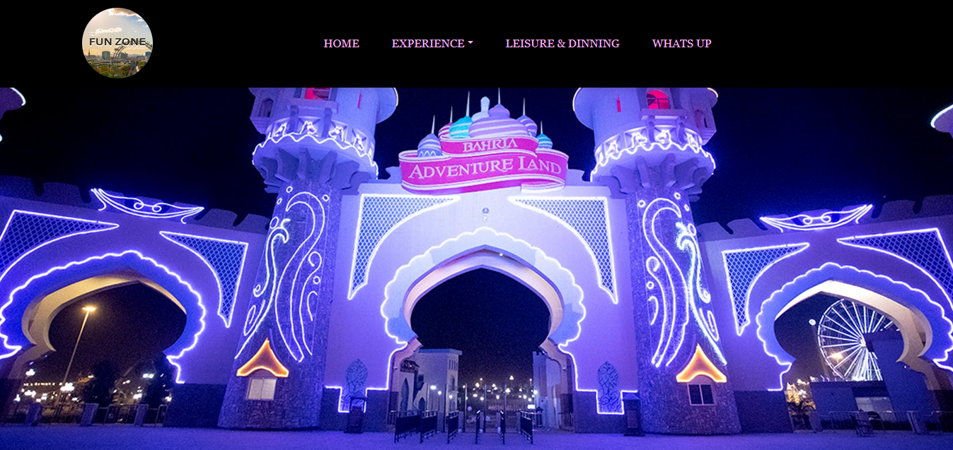

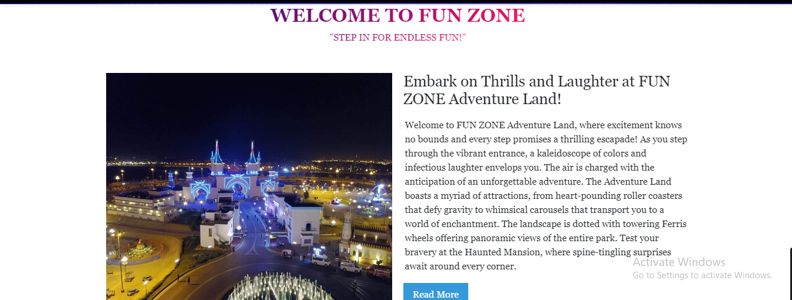

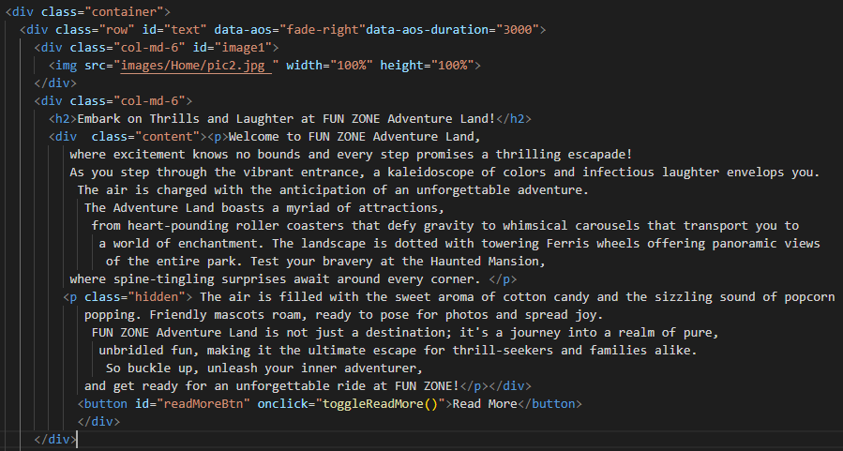

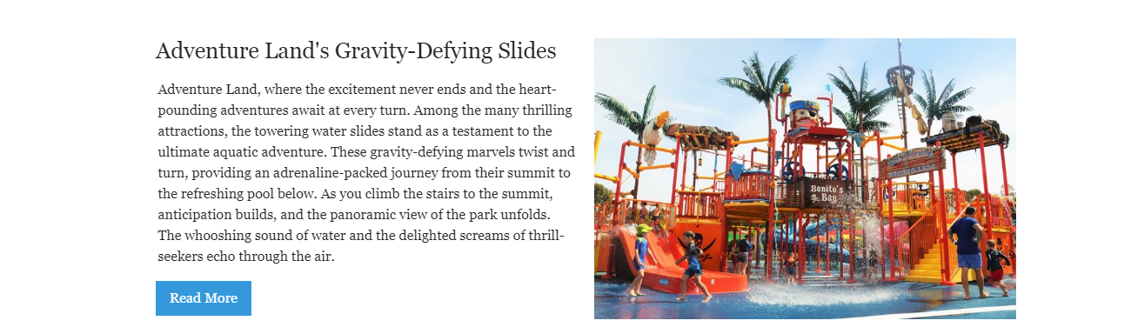

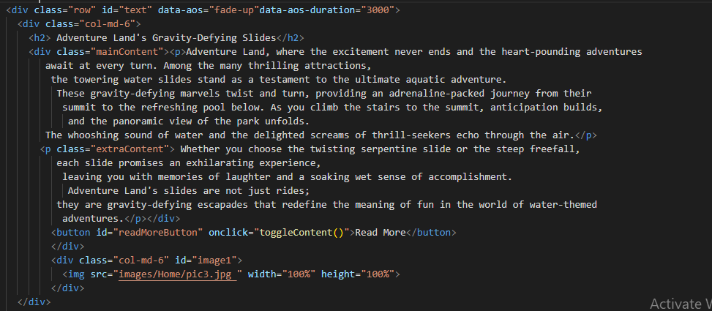

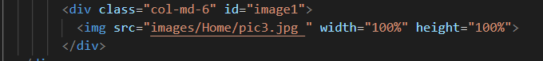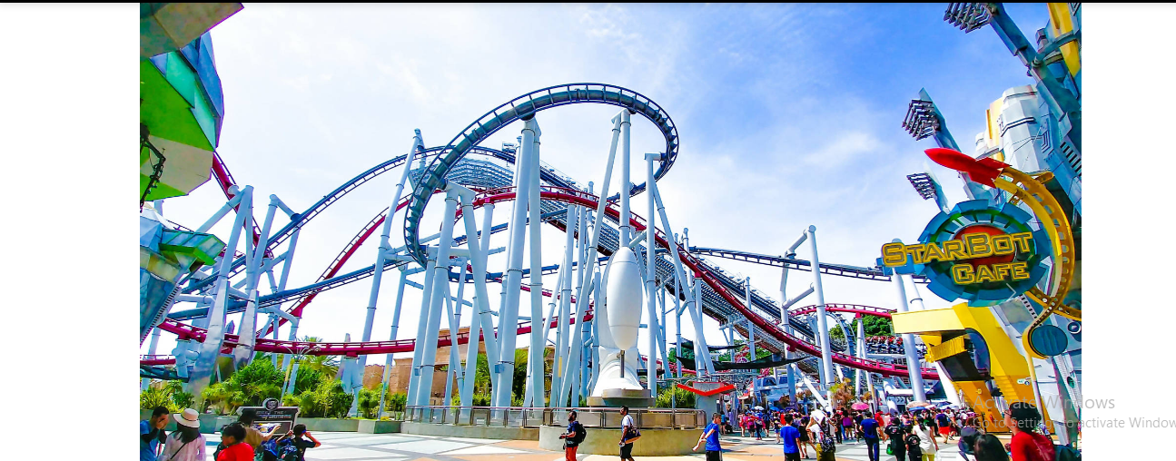

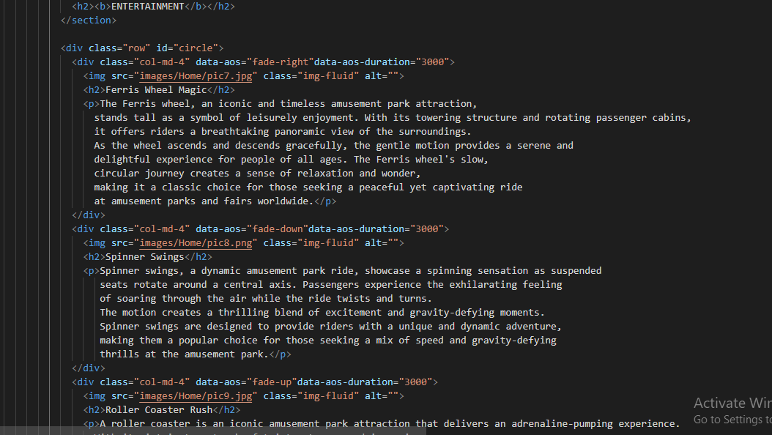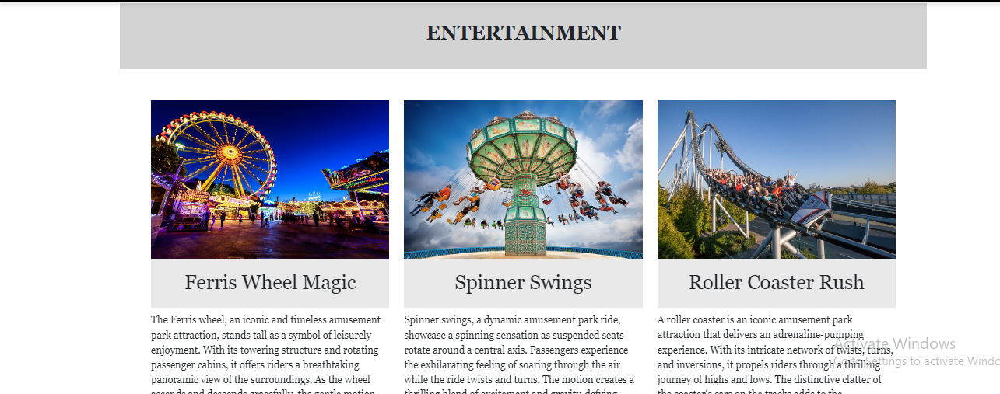

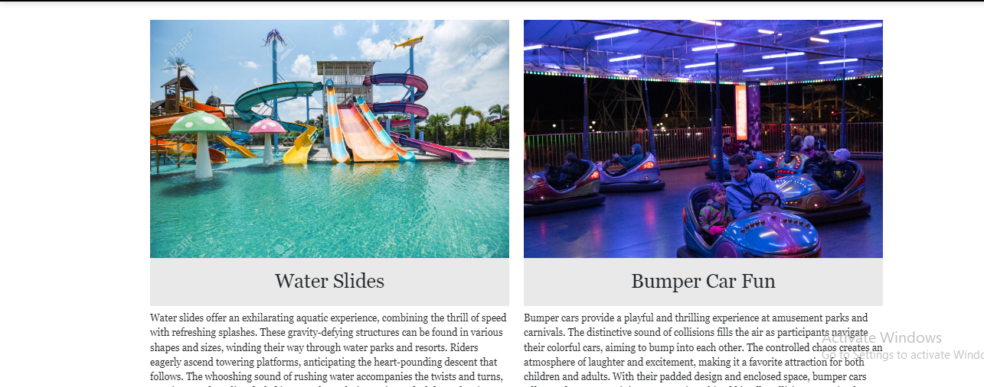

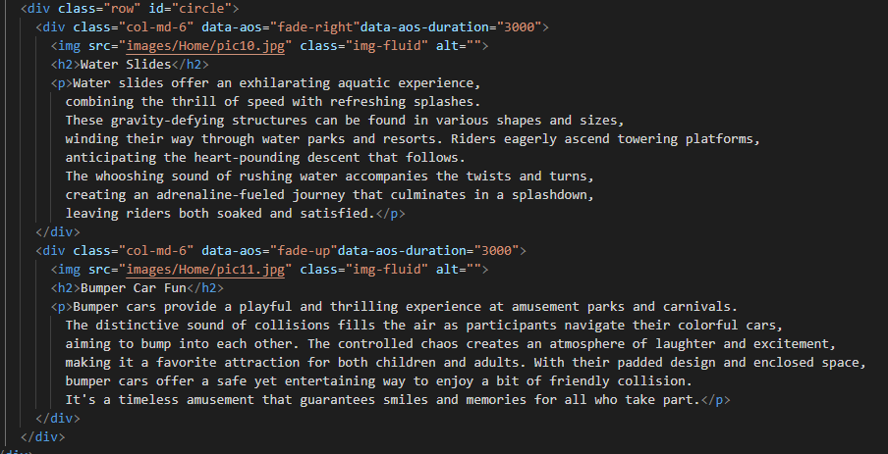

**Park Character**

